| Course name | Numerical Modeling & Simulation in Scilab Xcos |
| --- | --- |
| **Lesson name** | **Numerical Modelling of Ather Energy 450 using Acceleration data in Scilab-Xcos** |
| **Lesson objective** | **Practice blocks &** **acquaint to use GUI of Scilab-Xcos** |
| Created by | THATHIREDDY HEMANTH |

**Problem statement:** Model Ather Energy 450 for Acceleration data in Scilab Xcos to plot the Wheel Torque, Wheel Speed, Motor Torque, Motor Speed and Battery Current in Scilab-Xcos.

**Acceleration data Graph:**

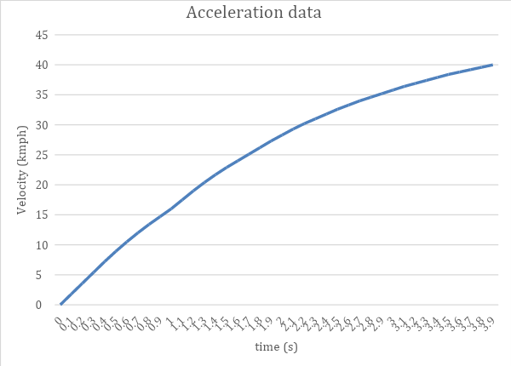

**Model Inputs:**

| **Sl No** | **Parameter** | **Value** | **Units** |
| --- | --- | --- | --- |
|  | **Chassis** |  |  |
|  | 1. Coefficient of rolling resistance | 0.015 |  |
|  | 1. Mass of Vehicle | 111 | Kg |
|  | 1. Mass of Driver | 80 | Kg |
|  | 1. Gravity constant | 9.81 | m/s |
|  | 1. Grade Angle | 0 | degree |
|  | 1. Velocity | From the Acceleration test data | Kmph |
|  | 1. Area | 0.875 | m^2 |
|  | 1. Air Density | 1.225 | Kg/m^3 |
|  | 1. Drag Coefficient | 0.22 |  |
|  | 1. Radius of wheel | 0.1524 | m |
|  | **Transmission** |  |  |
|  | 1. Gear Ratio | 7.8 |  |
|  | 1. Transmission Efficiency | 85 | % |
|  | **Motor** |  |  |
|  | Motor Efficiency | 90 | % |
|  | **Battery** |  |  |
|  | 1. Motor Controller Efficiency | 85 | % |
|  | 1. Battery Capacity | 2400 | Wh |
|  | 1. Battery Voltage | 51.1 | V |
|  | 1. Battery Initial SOC | 100 | % |
|  | 1. Drive Cycle time or Simulation time | 4 | s |
|  | **Cell** |  |  |
|  | 1. Cell Voltage | 3.6 | V |
|  | 1. Cell Capacity | 2.7 | Ah |

**Program:**

| 1. **To Import Acceleration Data:** | 1. **To define all input parameters:** |
| --- | --- |
| //Importing Drive_cycle data  data = csvRead("Acceleration.csv")  //Drive_cycle data  Drive_cycle,time = data(3:42,1)  Drive_cycle,values = data(3:42,2) | //Vehicle Dynamics  //Radius of the wheel  Rw = 0.1524 //m  //Coefficienct of rollign resistance  Crf = 0.015  //Gross Vehicle Mass  GVM = 191 //Kg  //Gravitational Constant  g = 9.81  //Gross Vehicle Weight  GVW = GVM*g  //Drag Coefficienct  Cd = 0.22  //Frontal Area  Area=0.875  //Transmission  //Gear Ratio  Gear_Ratio = 7.8  //Transmission Efficiency  Neff = 0.85 |

**Results:**

| **Rolling Force:** | **Gradeability Force:** |
| --- | --- |
|  |  |
| **Aerodynamic Force:** | **Acceleration Force:** |
|  |  |
| **Wheel Speed:** | **Wheel Torque:** |
|  |  |
| **Motor Speed:** | **Motor Torque:** |
|  |  |
| **Motor Power:** | **Battery Power:** |
|  |  |
| **Battery Current:** | **Battery SOC:** |
|  |  |
| **Battery C-rate:** |  |
|  |  |

**Conclusion:**

| **Sl No** | **Parameters** | **Values** | **Units** |
| --- | --- | --- | --- |
|  | **Chassis** |  |  |
|  | * Rolling Force | 28.105 | N |
|  | * Gradeability Force | 0 | N |
|  | * Maximum Aerodynamic Force | 14.556 | N |
|  | * Maximum Acceleration Force | 916.8 | N |
|  | * Maximum Wheel Speed | 696.215 | Rpm |
|  | * Maximum Wheel Torque | 144.008 | Nm |
|  | **Motor** |  |  |
|  | * Maximum Motor Speed | 5430.488 | Rpm |
|  | **Motor Torque** |  |  |
|  | * Maximum Motor Torque | 21.72 | Nm |
|  | **Motor Power** |  |  |
|  | * Maximum Motor Power | 6131.072 | W |
|  | **Battery** |  |  |
|  | * Battery Capacity in Ah | 47 | Ah |
|  | **Cell** |  |  |
|  | * Cell Voltage | 3.6 | V |
|  | * Cell Capacity | 2.7 | Ah |
|  | **No of cells** | 31 |  |
|  | **Battery Power** |  |  |
|  | * Maximum Battery Power | 7213.0263 | W |
|  | **Battery Current** |  |  |
|  | * Maximum Battery Current | 141.155 | A |
|  | **Battery C-rate** |  |  |
|  | * Maximum Battery Discharge C-rate | 3 | C |
|  | * State of Charge | 99.77 | % |